Unit 4 Chemistry Test: Proteins and plants
Name: ________________________ Mark: __/50
Section A: Multiple Choice
Question 1
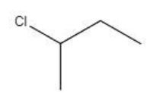
Correct answer: C.
The chiral carbon is marked with an asterisk.

Question 2
Correct answer: D
NH₂ can form an ionic bond or it can form a hydrogen bond with an R group such as serine.

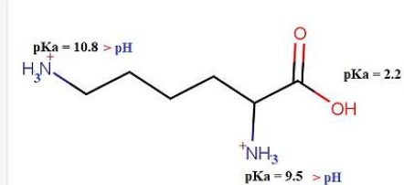
Question 3
Correct answer: B

Question 4
Correct answer: B
The use of hexane in the margarine and other oil industry is high. As a non-polar solvent it extracts non-polar oil.

Question 5
Correct answer: A
A has both a hydroxyl group and a carbonyl group

Question 6
Correct answer: B
The heat denatures protein in milk causing it to form a skin. The reaction is not unlike the change in appearance of egg white when eggs are cooked.

Question 7
Correct answer: D
Enzymes such as amylase and pepsin operate best at pH 8 and 2 respectively.

Question 8
Correct answer: C
Too hard to study forty components at once so work on obtaining pure samples.

Question 9
Correct answer: A
Initially the reaction becomes faster due to more collisions but then slows due to the denaturing of catalase.
Question 10
Correct answer: B
Each enzyme can act many times.

Section B

Question 1 (10 marks)
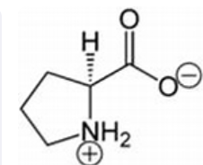
a. i. 1 mark

ii. At pH 12 the NH₂⁺ become NH. 1 mark

b. i. 2 marks

ii. When two amino acids bond, there re two different dipeptides that can form, depending upon which amino acid you draw on the left. The two products are structural isomers. 1 mark

iii. Secondary bonding is hydrogen bonding between the peptide links on different parts of the protein molecule. It causes the protein to form either a helix or a pleated sheet. 2 marks

c. i. The hydroxyl bond on the first amino acid can form hydrogen bonds with other R groups.
The second R-group is non-polar and will only form weaker dispersion forces. 2 marks

ii. cysteine can form covalent disulfide bonds with other cysteine R groups 1 mark

Question 2 (8 marks)
a. i. THC is not highly polar. One hydroxyl group and one oxygen atom in a large molecule will lead to low polarity overall. The solvent should try and match the polarity of THC, so a weakly polar solvent. Like dissolves like. Ethanol is likely to be too polar, chloroethane might be more suitable.
3 marks

ii. Chromatography is likely to be used to separate THC from other ingredients. The solubility of the molecules in a polar mobile phase will determine the retention time in the column. The more polar the molecule, the lower the retention time. 2 marks

b. i. The melting point of THC is 66 ºC. If you extract a sample, you can test its melting point. It will be close to 66 ⁰C and have a narrow range if pure. As impurity levels increase, the melting point range will increase. 2 marks

ii. The hydroxyl group will lead to a broad absorption around 3300 cm⁻¹. 1 mark

Question 3 (12 marks)

a. i. These two molecules are optical isomers. They have a chiral carbon that connects to the hydroxyl group. The different spatial arrangement around this chiral carbon leads to the two enantiomers that cannot be superimposed. 3 marks

ii. The viscosity will be the same. The rotation of polarised light is the only different property. 2 marks

iii.

These are structural isomers where the hydroxyl group is in an obvious different position. The optical isomers have different spatial arrangements. 2 marks

b. i. To the human body the two enantiomers might as well be different molecules. Only one has the correct arrangement to match the active site. 2 marks

ii. See which way it rotates polarised light. 1 mark

c. Naproxen has a shape the enables it to fit the active site of an enzyme that creates inflammation. As the active site is blocked, inflammation does not form
2 marks
Question 4 (10 marks)

a. i. Enzymes have characteristic performance with pH. They have an optimum operating pH. However, the pH at which the optimum occurs varies with the enzyme and where it is operating. 2 marks

ii. The response to pH is a consequence of the mix of R – groups in the protein. The zwitterion action and acid/base properties of the R groups differs. 1 mark

b. i. Characteristic shape – the rate initially increases with temperature as the particles move faster and collide more. Eventually the extra energy starts to impact the 3D structure of the enzyme and the effectiveness of the catalyst drops. The enzyme is being denatured – the tertiary and secondary structure falling away. 4 marks

ii. Nature looks after species – Antarctic animals would all die if they had normal enzymes that operate at 37 ⁰C. 1 mark

c. The graph shows that initially the rate increases with concentration but then it plateaus where there is little gain for increased concentration. 2 marks

